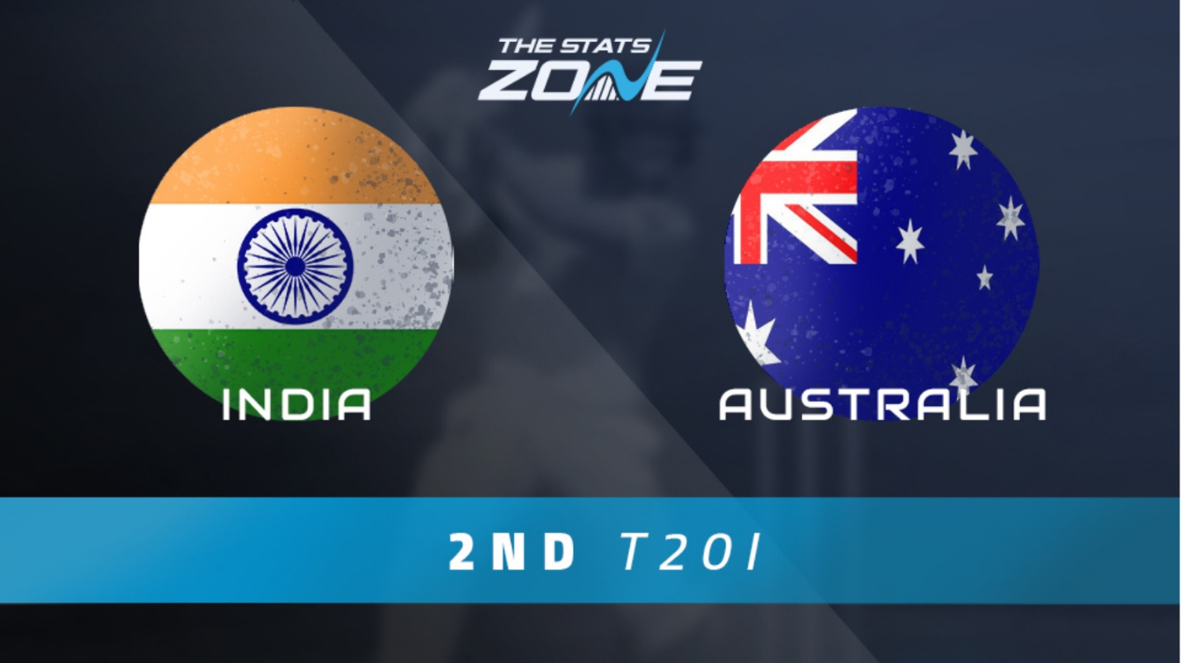

***Report Title: Insights on India vs. Australia Cricket Match: Fan Sentiments and Predictions***

***Introduction****:*

*This report summarizes the sentiments and predictions of cricket fans regarding the India vs. Australia match. The findings are based on a series of questions posed to enthusiasts, providing valuable insights into their opinions and preferences.*

*Section 1: Fan Sentiments*

*1. Excitement Level: Overwhelmingly positive, with respondents expressing high excitement for the match.*

*2. Favorite Match-Day Food: Pizza with Coca-Cola and popcorn with Pepsi emerged as top choices.*

*3. Preferred Viewing Experience: Watching live at the stadium narrowly edged out watching from home.*

*Section 2: Match Predictions*

*1. Predicted Winner: India (cited as the favored team).*

*2. Man of the Match: Virat Kohli (narrowly edged out Rishabh Pant).*

*3. Key Players: Hardik Pandya and Ravindra Jadeja recognized as crucial players.*

*Section 3: Cricket Enthusiasm*

*1. What Drives Interest: The thrill of the game and player skill were top motivators.*

*2. Confidence in Indian Team: Respondents expressed optimism about India's chances.*

*Section 4: Demographics*

*1. Age Group: Respondents primarily fell within the 20-30 age range.*

*2. Gender: Male respondents outnumbered female respondents.*

*Conclusion:*

*This report highlights the electric atmosphere surrounding the India vs. Australia cricket match. Fans are enthusiastic, confident in India's chances, and eager to enjoy the game with friends, family, and favorite snacks.*

*Report Title: Insights on India vs. Australia Cricket Match: Fan Sentiments and Predictions*

*Introduction:*

*This report summarizes the sentiments and predictions of cricket fans regarding the India vs. Australia match. The findings are based on a series of questions posed to enthusiasts, providing valuable insights into their opinions and preferences.*

*Section 1: Fan Sentiments*

*1. Excitement Level: Overwhelmingly positive, with respondents expressing high excitement for the match.*

*2. Favorite Match-Day Food: Pizza with Coca-Cola and popcorn with Pepsi emerged as top choices.*

*3. Preferred Viewing Experience: Watching live at the stadium narrowly edged out watching from home.*

*Section 2: Match Predictions*

*1. Predicted Winner: India (cited as the favored team).*

*2. Man of the Match: Virat Kohli (narrowly edged out Rishabh Pant).*

*3. Key Players: Hardik Pandya and Ravindra Jadeja recognized as crucial players.*

*Section 3: Cricket Enthusiasm*

*1. What Drives Interest: The thrill of the game and player skill were top motivators.*

*2. Confidence in Indian Team: Respondents expressed optimism about India's chances.*

*Section 4: Demographics*

*1. Age Group: Respondents primarily fell within the 20-30 age range.*

*2. Gender: Male respondents outnumbered female respondents.*

*Conclusion:*

*This report highlights the electric atmosphere surrounding the India vs. Australia cricket match. Fans are enthusiastic, confident in India's chances, and eager to enjoy the game with friends, family, and favorite snacks.*